ANUKEERTHANA S

Module 6 - Spring Data JPA with Spring Boot, Hibernate
Spring Data JPA - Quick Example
Project Structure
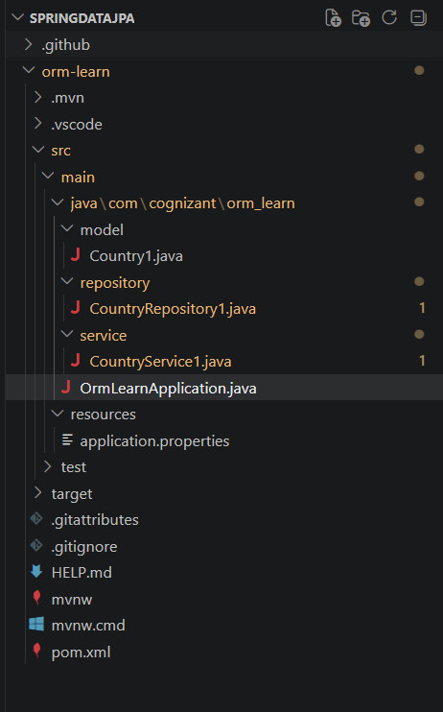
Entity
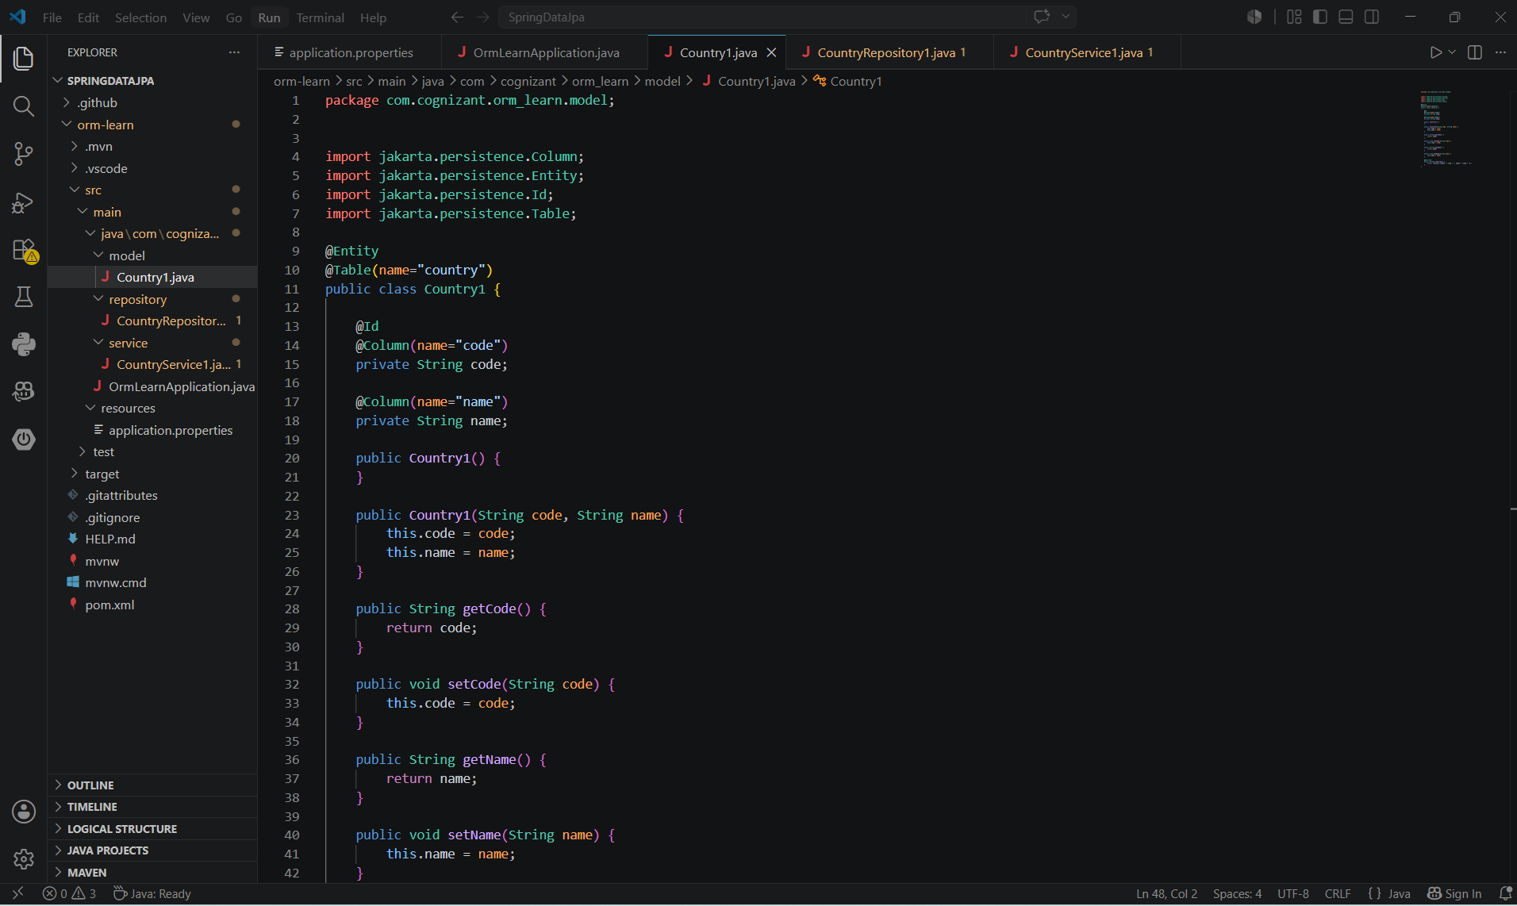
Repository
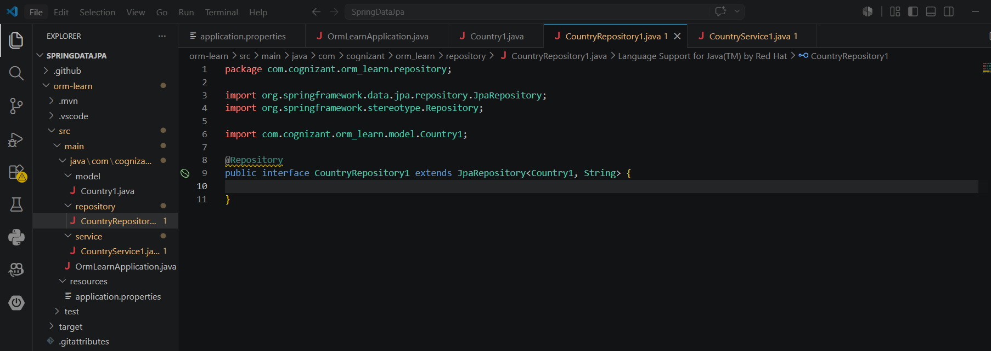
Service
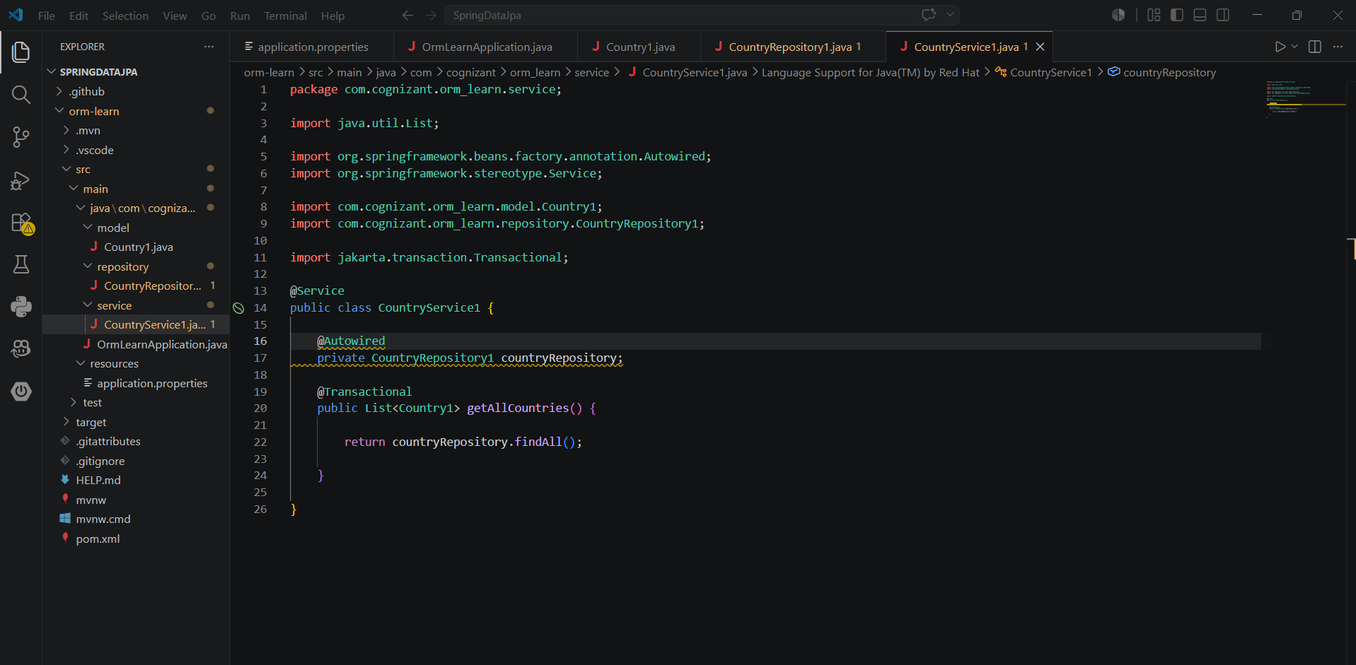
Output
